**Circuitos Semáforos**

**Nome: Gustavo Afonso de Almeida n°07**

**Primeiro Circuito:**

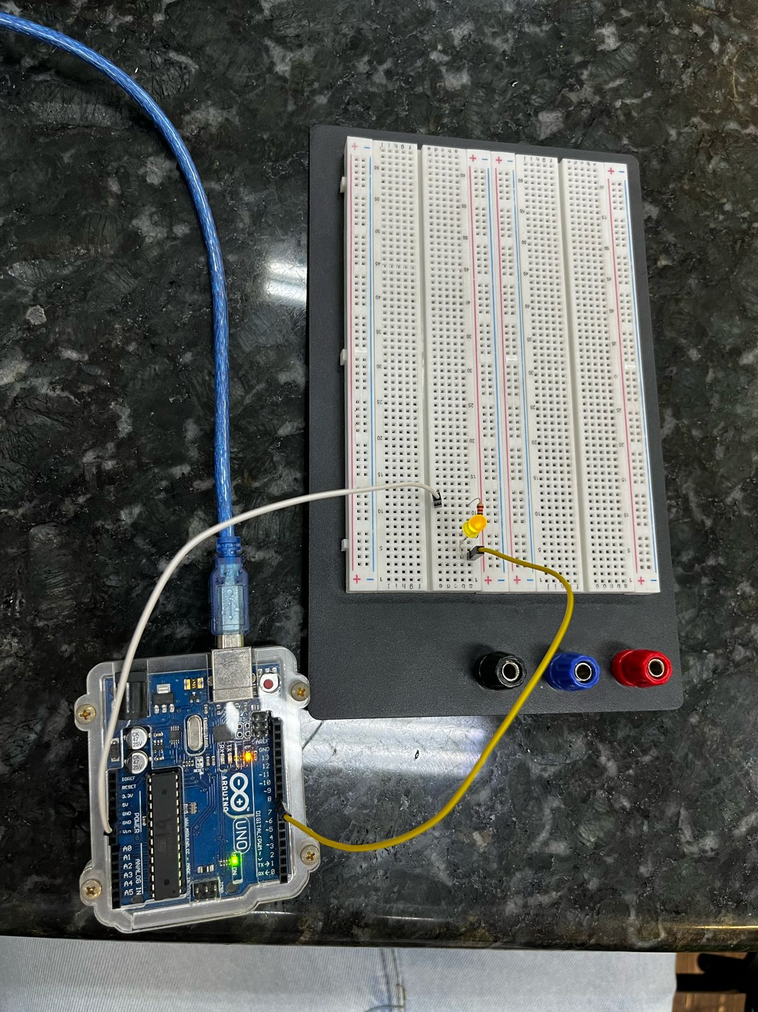

void setup() {

pinMode(8, OUTPUT);

}

void loop() {

digitalWrite(10, HIGH);

delay(100);

**Segundo Circuito:**

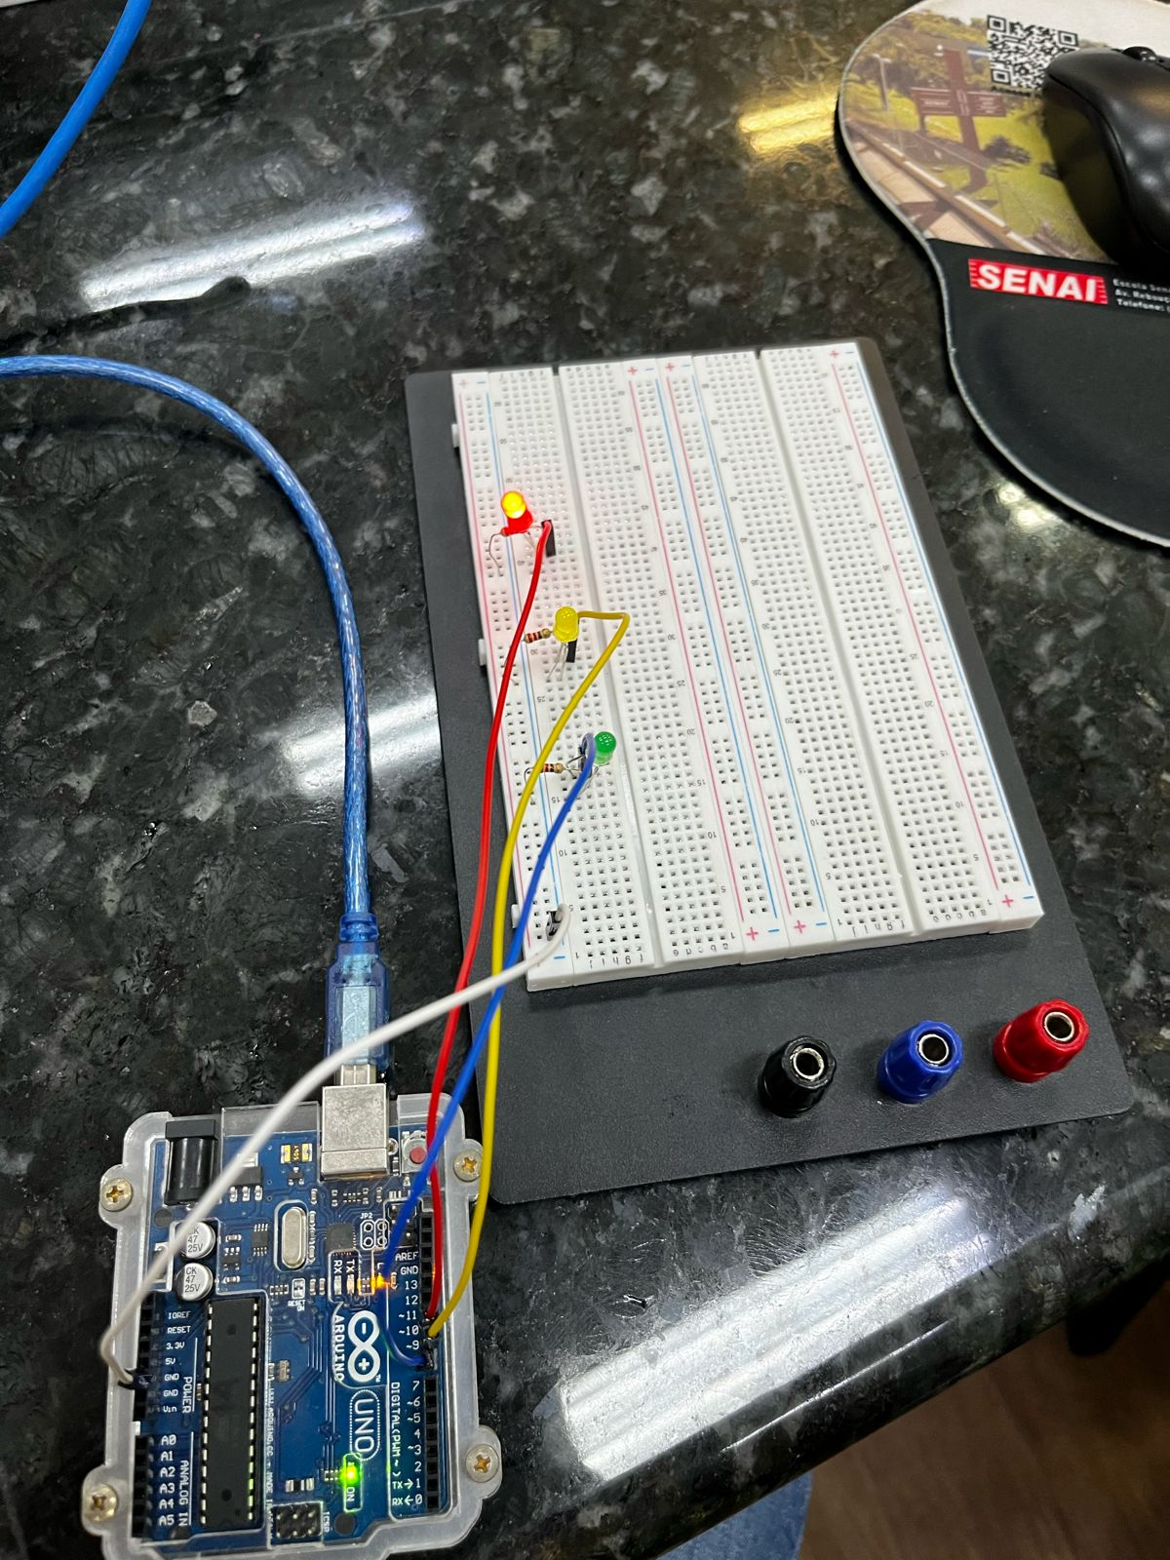

void setup() {

pinMode(10, OUTPUT);

pinMode(9, OUTPUT);

pinMode(8, OUTPUT);

}

void loop() {

digitalWrite(10, LOW);

digitalWrite(9, HIGH);

digitalWrite(8, LOW);

delay(800);

digitalWrite(10, HIGH);

digitalWrite(9, LOW);

digitalWrite(8, LOW);

delay(2500);

digitalWrite(10, LOW);

digitalWrite(9, LOW);

digitalWrite(8, HIGH);

delay(2500);

}

**Terceiro Circuito:**



void setup() {

pinMode(10, OUTPUT); // veremlho

pinMode(9, OUTPUT); // amarelo

pinMode(8, OUTPUT); // verde

pinMode(6, OUTPUT); // vermelho

pinMode(5, OUTPUT); // amarelo

pinMode(4, OUTPUT); // verde

}

void loop() {

digitalWrite(10, HIGH);//SEMÁFORO(1)

digitalWrite(9, LOW);//SEMÁFORO(1)

digitalWrite(8, LOW);//SEMÁFORO(1)

digitalWrite(6, LOW);//SEMÁFORO(2)

digitalWrite(5, LOW);//SEMÁFORO(2)

digitalWrite(4, HIGH);//SEMÁFORO(2)

delay(2500);

digitalWrite(10, HIGH);//SEMÁFORO(1)

digitalWrite(9, LOW);//SEMÁFORO(1)

digitalWrite(8, LOW);//SEMÁFORO(1)

digitalWrite(6, LOW);//SEMÁFORO(2)

digitalWrite(5, HIGH);//SEMÁFORO(2)

digitalWrite(4, LOW);//SEMÁFORO(2)

delay(2500);

digitalWrite(10, LOW);//SEMÁFORO(1)VERMELHO

digitalWrite(9, LOW);//SEMÁFORO(1)AMARELO

digitalWrite(8, HIGH);//SEMÁFORO(1)VERDE

digitalWrite(6, HIGH);//SEMÁFORO(2)VERMELHO

digitalWrite(5, LOW);//SEMÁFORO(2)AMARELO

digitalWrite(4, LOW);//SEMÁFORO(2)VERDE

delay(2500);

digitalWrite(10, LOW);//SEMÁFORO(1)

digitalWrite(9, HIGH);//SEMÁFORO(1)

digitalWrite(8, LOW);//SEMÁFORO(1

digitalWrite(6, HIGH);//SEMÁFORO(2)

digitalWrite(5, LOW);//SEMÁFORO(2)

digitalWrite(4, LOW);//SEMÁFORO(2)

delay(2500);

}

**Quarto Circuito:**

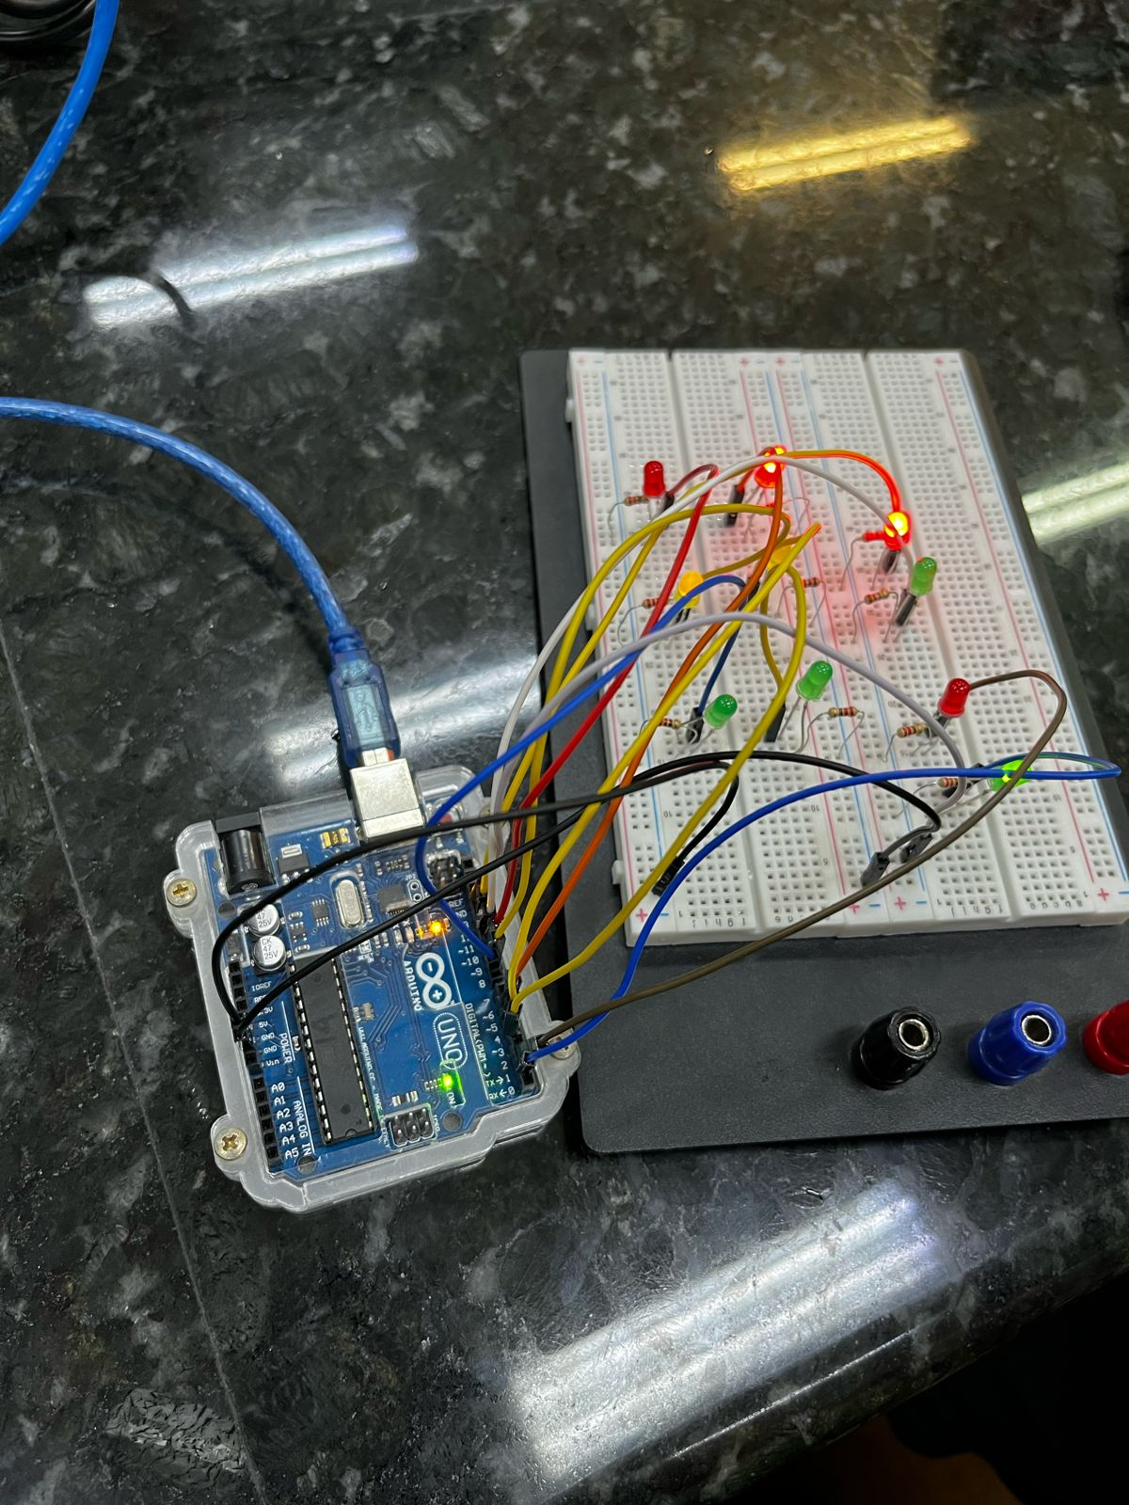

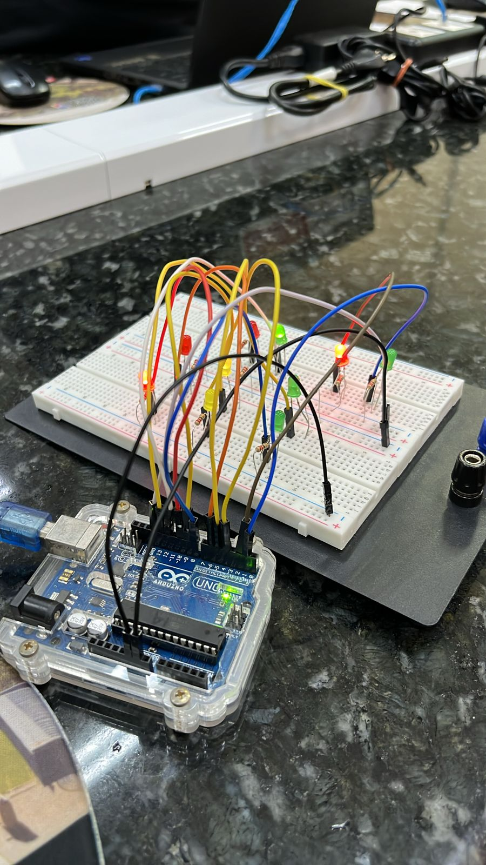

void setup() {

pinMode(10, OUTPUT); // veremlho

pinMode(9, OUTPUT); // amarelo

pinMode(8, OUTPUT); // verde

pinMode(6, OUTPUT); // vermelho

pinMode(5, OUTPUT); // amarelo

pinMode(4, OUTPUT); // verde

pinMode(2, OUTPUT);//PedestresDireita-Vermelho1

pinMode(1, OUTPUT);//PedestresDireita-Verde1

pinMode(13, OUTPUT);//PedestresEsquerda-Vermelho2

pinMode(12, OUTPUT);//PedestresEsquerda-Verde2

}

void loop()

{

digitalWrite(10, HIGH);//SEMÁFORO(1)

digitalWrite(9, LOW);//SEMÁFORO(1)

digitalWrite(8, LOW);//SEMÁFORO(1)

digitalWrite(6, LOW);//SEMÁFORO(2)

digitalWrite(5, LOW);//SEMÁFORO(2)

digitalWrite(4, HIGH);//SEMÁFORO(2)

digitalWrite(2, HIGH);

digitalWrite(1, LOW);

digitalWrite(13, LOW);

digitalWrite(12, HIGH);

delay(2500);

digitalWrite(10, HIGH);//SEMÁFORO(1)

digitalWrite(9, LOW);//SEMÁFORO(1)

digitalWrite(8, LOW);//SEMÁFORO(1)

digitalWrite(6, LOW);//SEMÁFORO(2)

digitalWrite(5, HIGH);//SEMÁFORO(2)

digitalWrite(4, LOW);//SEMÁFORO(2)

digitalWrite(2, HIGH);//verde

digitalWrite(1, LOW);//vermelho

digitalWrite(13, LOW);

digitalWrite(12, HIGH);

delay(2500);

digitalWrite(10, LOW);//SEMÁFORO(1)VERMELHO

digitalWrite(9, LOW);//SEMÁFORO(1)AMARELO

digitalWrite(8, HIGH);//SEMÁFORO(1)VERDE

digitalWrite(6, HIGH);//SEMÁFORO(2)VERMELHO

digitalWrite(5, LOW);//SEMÁFORO(2)AMARELO

digitalWrite(4, LOW);//SEMÁFORO(2)VERDE

digitalWrite(2, LOW);

digitalWrite(1, HIGH);

digitalWrite(13, HIGH);

digitalWrite(12, LOW);

delay(2500);

digitalWrite(10, LOW);//SEMÁFORO(1)

digitalWrite(9, HIGH);//SEMÁFORO(1)

digitalWrite(8, LOW);//SEMÁFORO(1

digitalWrite(6, HIGH);//SEMÁFORO(2)

digitalWrite(5, LOW);//SEMÁFORO(2)

digitalWrite(4, LOW);//SEMÁFORO(2)

digitalWrite(2, LOW);

digitalWrite(1, HIGH);

digitalWrite(13, HIGH);

digitalWrite(12, LOW);

delay(2500);

}